**Business Scenario:**

As per the business requirement we need to add some custom fields on standard FIORI apps (i.e., Manage Purchase Requisition Professional App). As per SAP best practises we need to use standard custom fields and logic app to add fields to standard FIORI apps. This app will take care of adding fields to respective tables, classes, CDS views and OData services. The app will also take care of all CRUD functionality and draft feature of FIORI elements apps.

**Changes Required from Front-End (FIORI):**

**Custom Fields and Logic App(F1481):**

1. Using this App, we can add custom fields of different types and enable fields to be used in different UI reports, GUI T-Code’s, and Business scenarios. We can find more about this app in below URL.

<https://fioriappslibrary.hana.ondemand.com/sap/fix/externalViewer/#/detail/Apps('F1481')/S18OP>

1. Before using this app, we need to perform some activities for ex. Capture changes done in custom fields logic app in some package and move these changes to predefined package and TR. For that we need to setup Adaptation Transport Organizer using TCODE (TCODE(S_ATO_SETUP)
2. SAP Help: -

<https://help.sap.com/viewer/b4367b1cec3243c4989f0ff3d727c4ab/7.5.8/en-US/57909455bf7c4fdd8bcf48d76c1eae33.html>

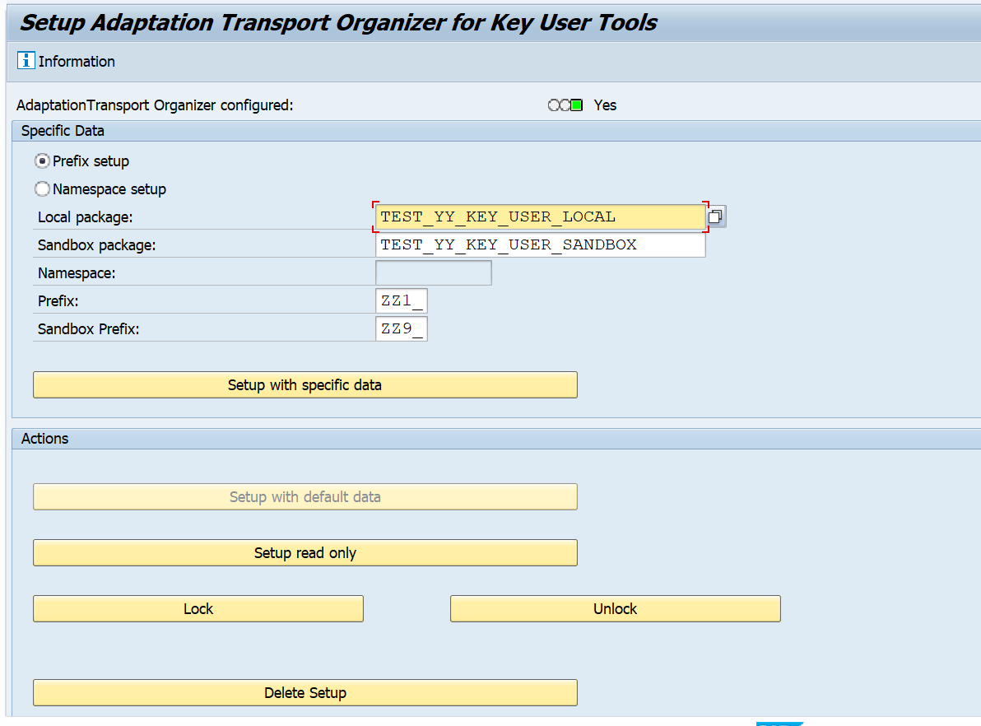

1. In this application, we can create custom fields for the corresponding business context.

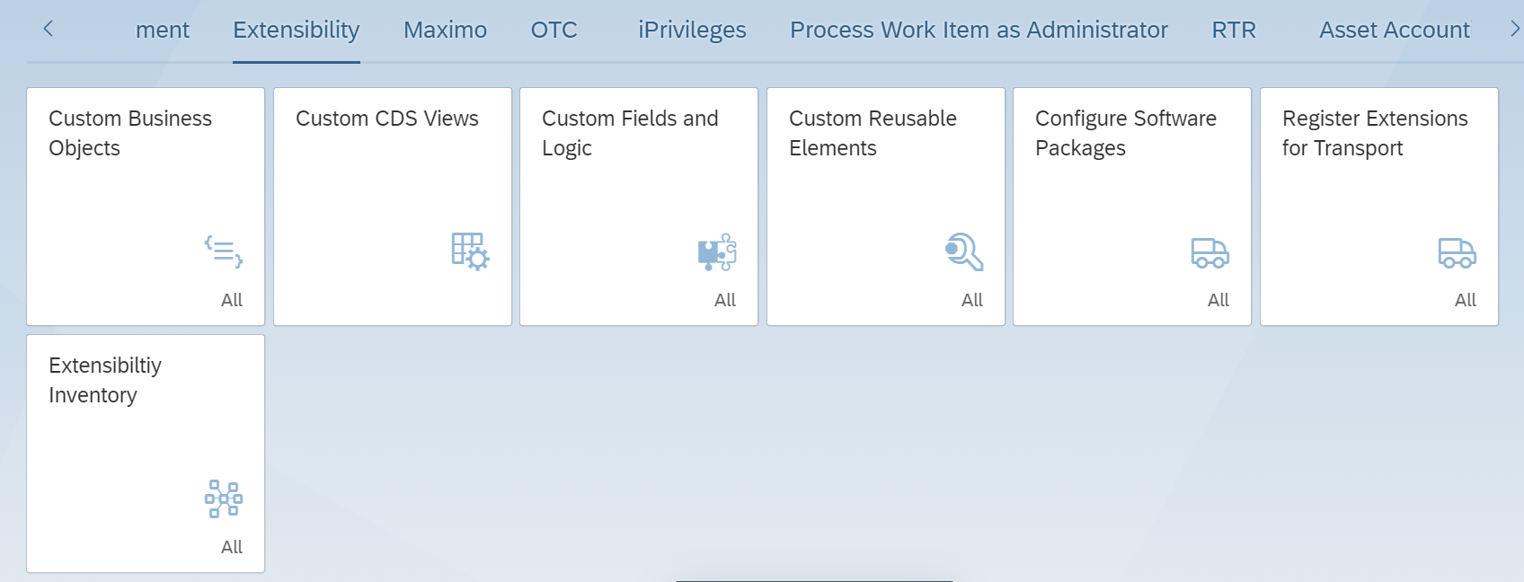

1. Below is the screen shot of Custom Fields and Logic App.

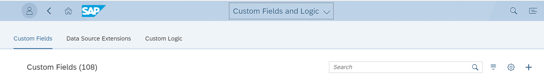

1. We can create new custom fields based on some business context. By clicking on Add button on right side of the screen.

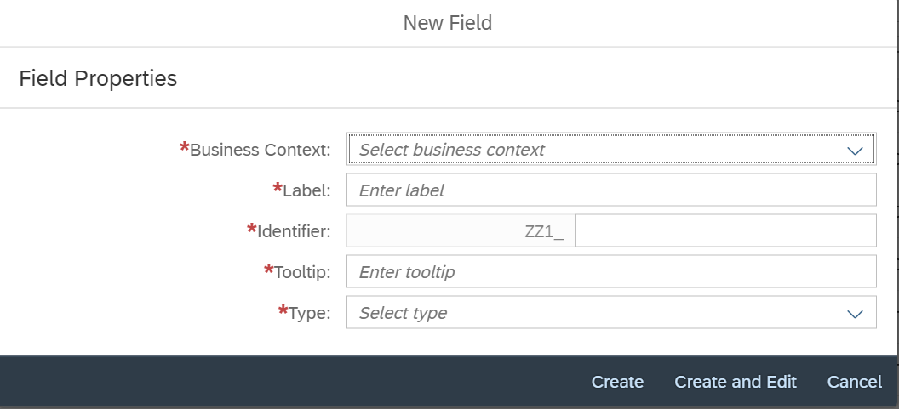

1. We can select the business context based on our standard FIORI app. Business Context and Standard App relationship can be found in FIORI reference apps.
2. We will take Procurement Purchase Requisition Item as business context for creating custom fields in EBAN table.
3. We can select type of custom fields from drop down list.

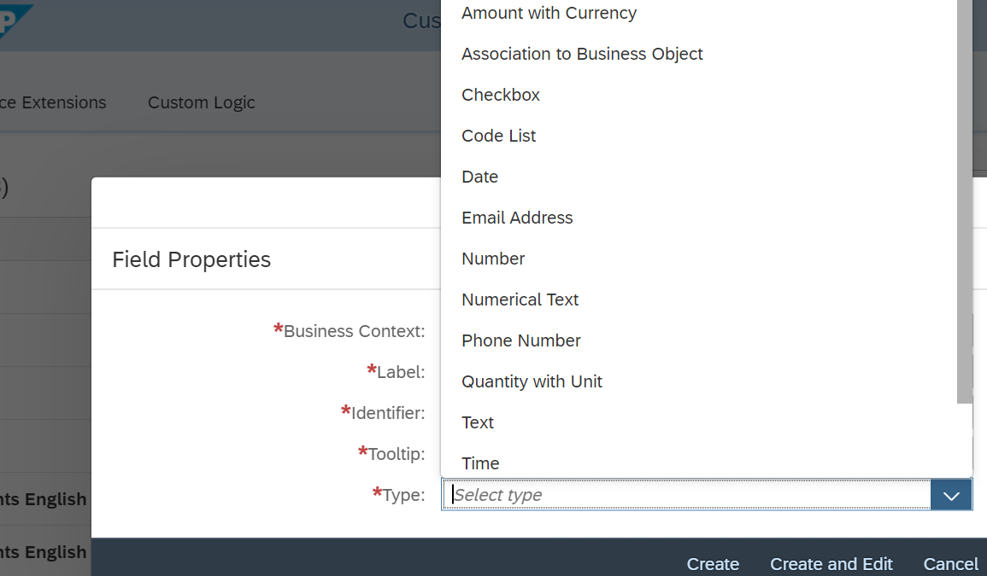

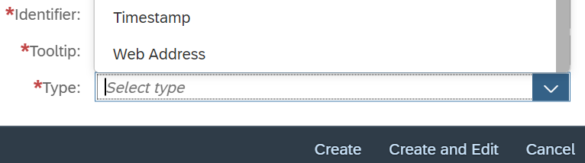

1. Fill all the required fields and click on Create and Edit button.

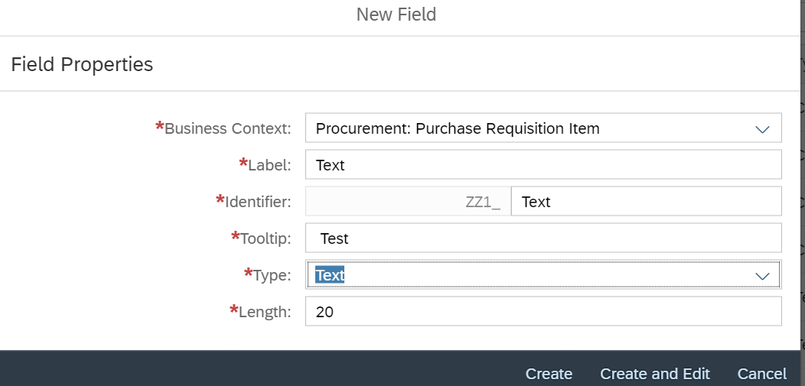

1. It will open another screen, where we can enable this field for different FIORI apps and TCODE.

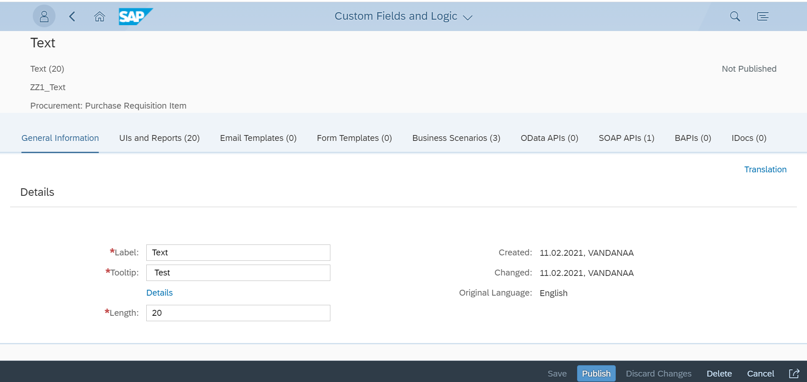

1. Click on UIs and Reports tab, we can enable each report and TCODE based on our requirement. It will enable custom fields in Manage Purchase Requisition Professional App.

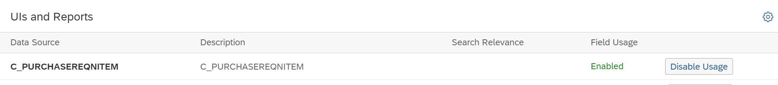

1. It will enable custom fields in ME51N/ME52N/ME53N TCODE.



1. Go to Business Scenarios tab, to enable to flow data from PR to PO.

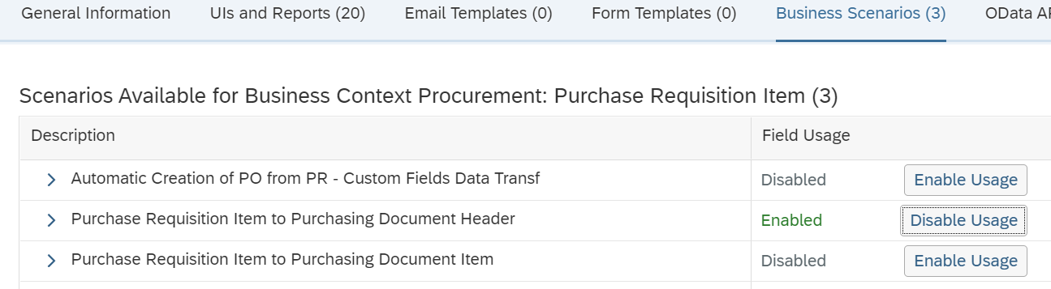

1. We can click on Translation tab, to maintain translations for that fields.

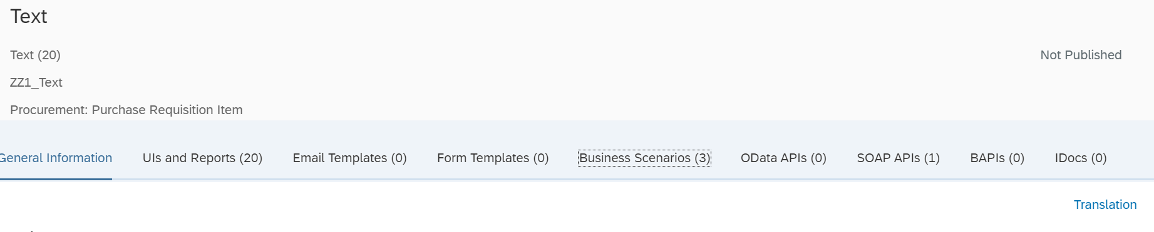

1. We can select the language and add translations for the fields.

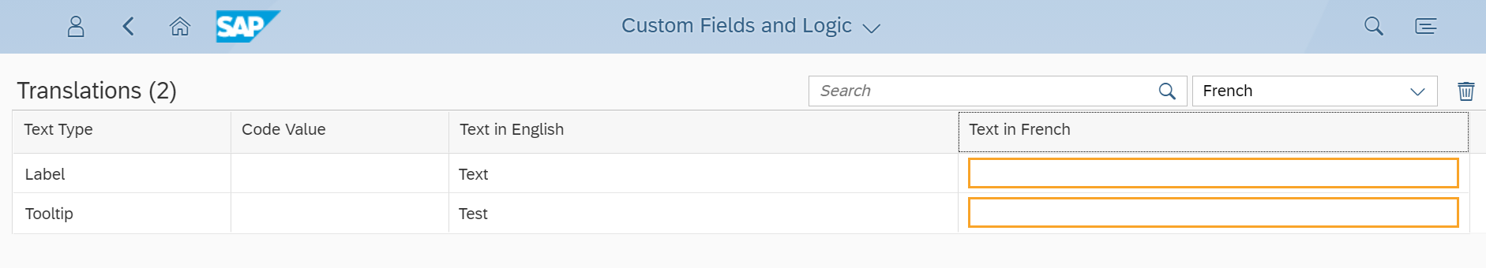

1. Finally, we can click on Submit button, it will trigger background job to create data elements and fields to add it to respective CDS views and Reports.

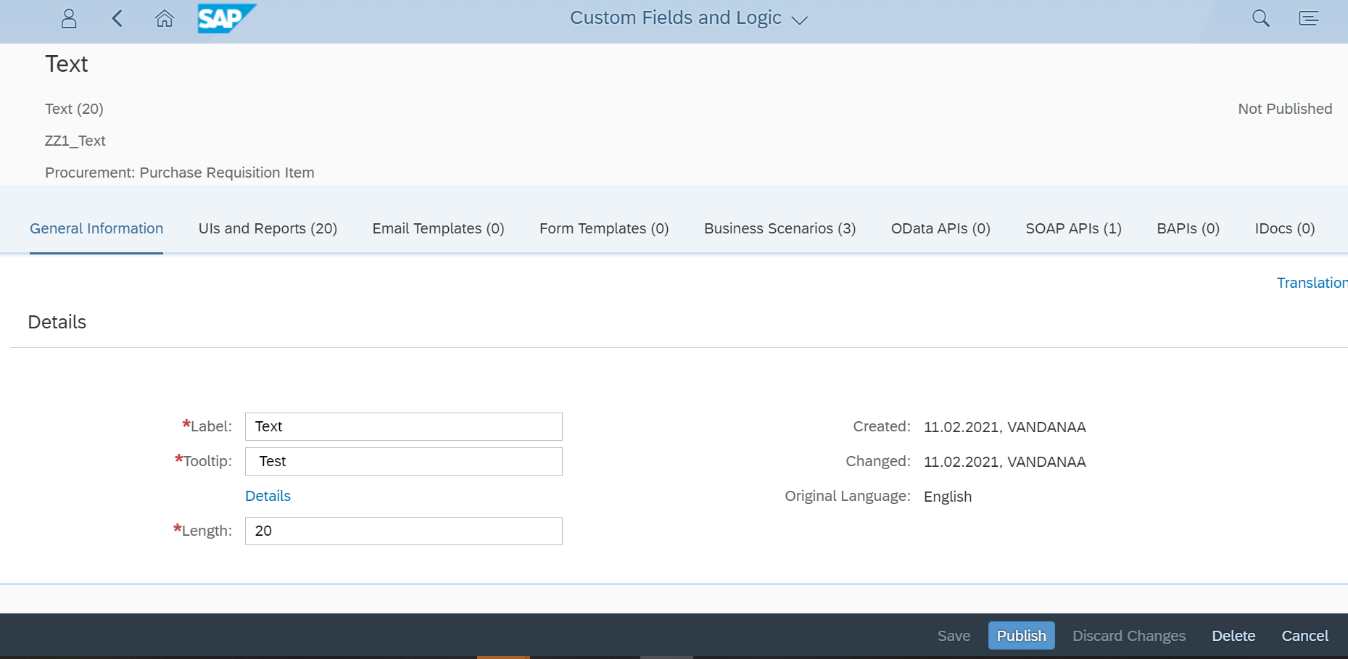



1. We can check Job status for field creation using TCODE(SM37).

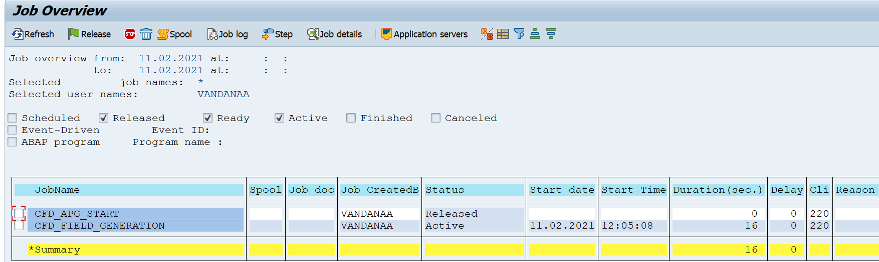

1. Once custom field is created, job will be completed.

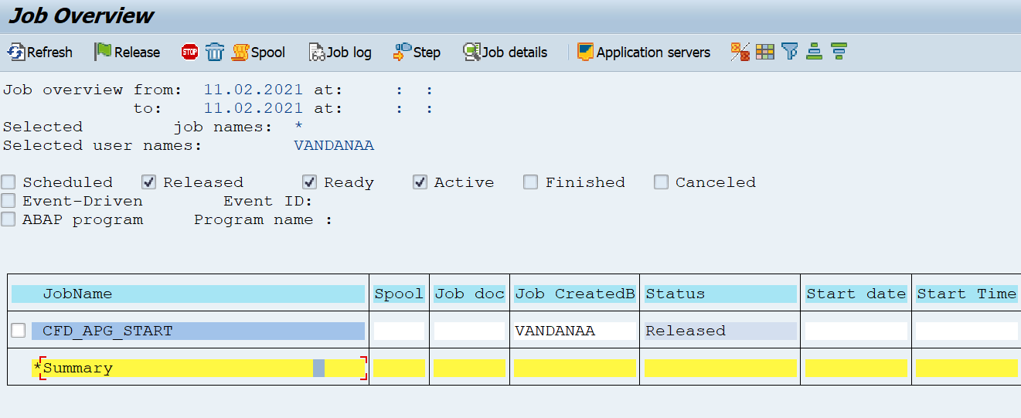

1. We can check created field in SE11.

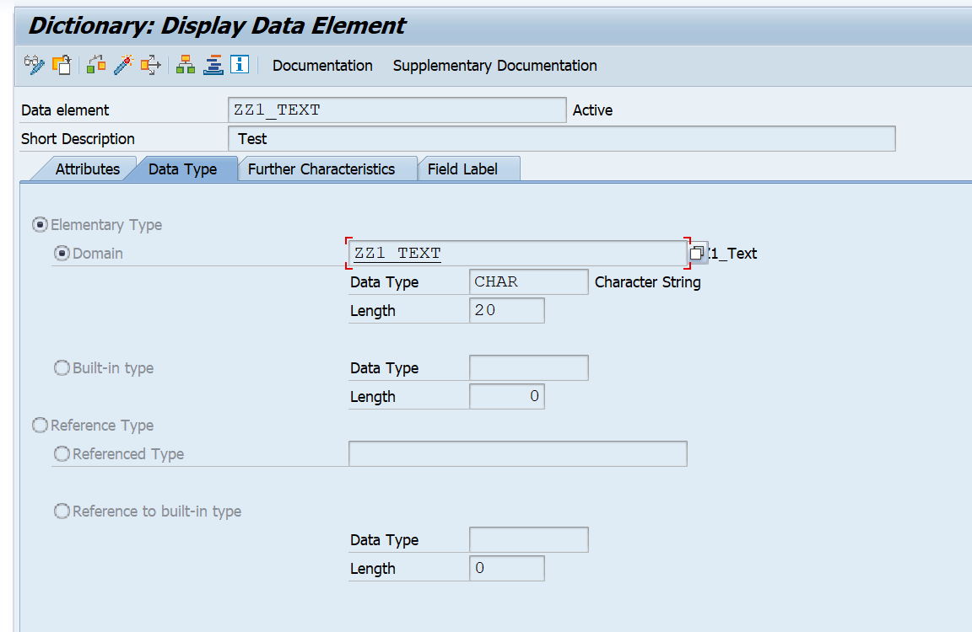

1. Custom field is added in EBAN table(PREQ Standard table).

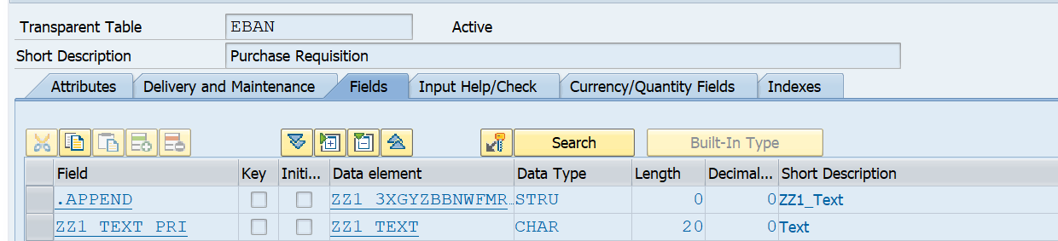

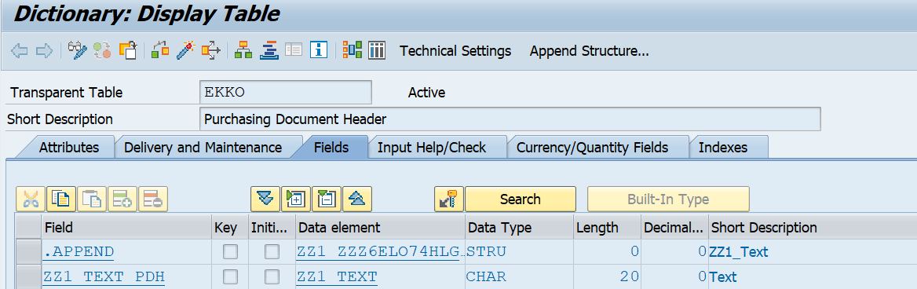

1. SAP will automatically create Custom Fields tab at Item level in backend TCODE with all our custom fields in that tab.

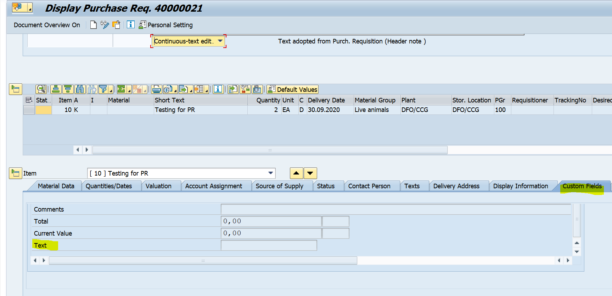

1. If we open C_PurchaseReqnItem CDS view, we can see our custom field are added as CDS extension view.

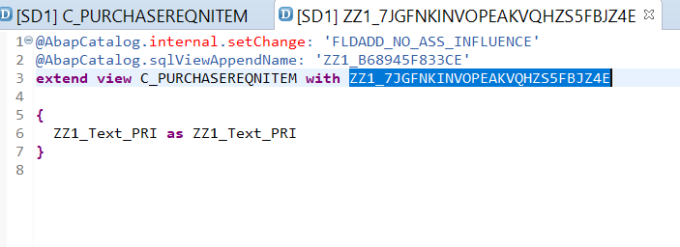

**Configure Software Packages:**

1. After creation of custom field, we can move that changes to another package and Transport.

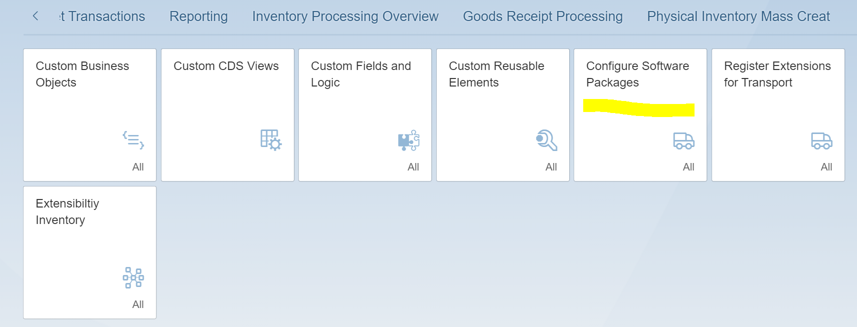

1. Click on Configure Software Packages app and click on Add Registration button from toolbar. We can select the package from list.

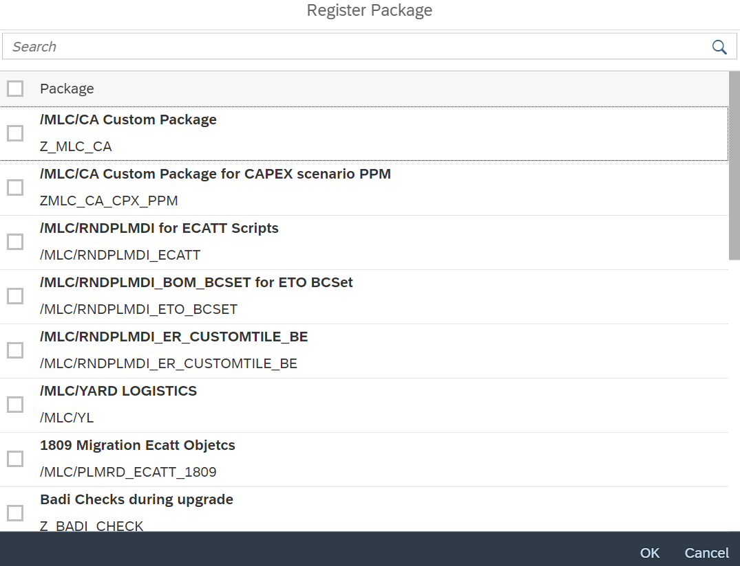

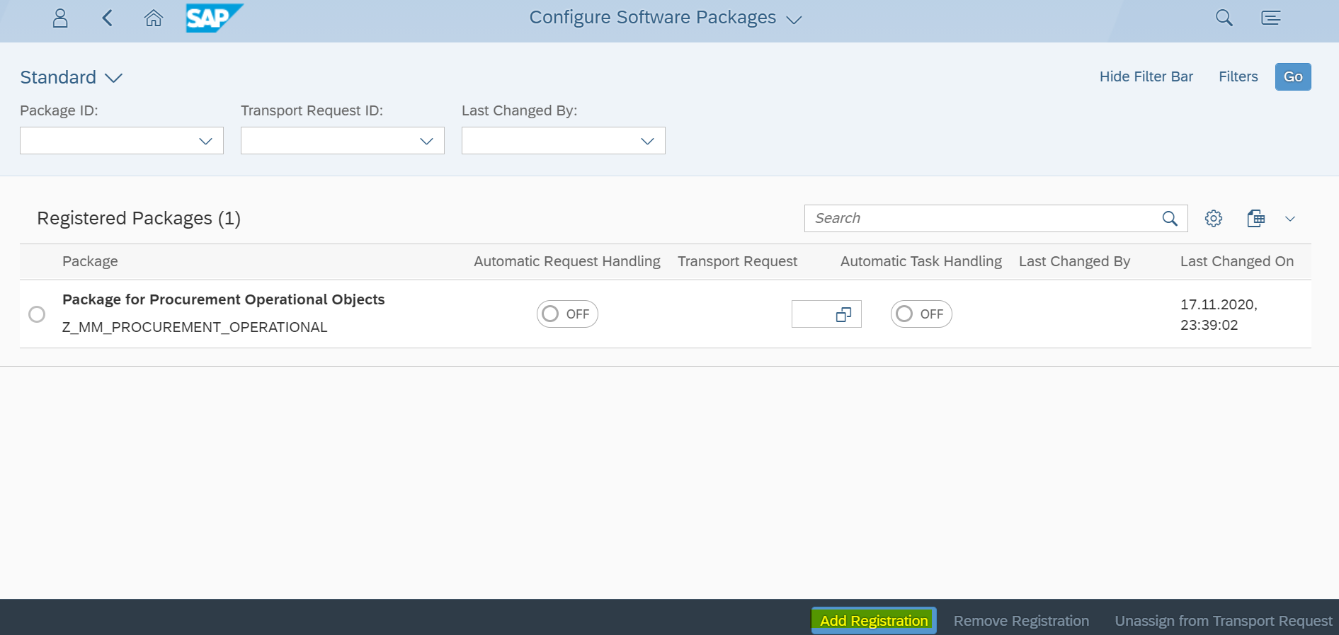

**Register Extensions for Transport:**

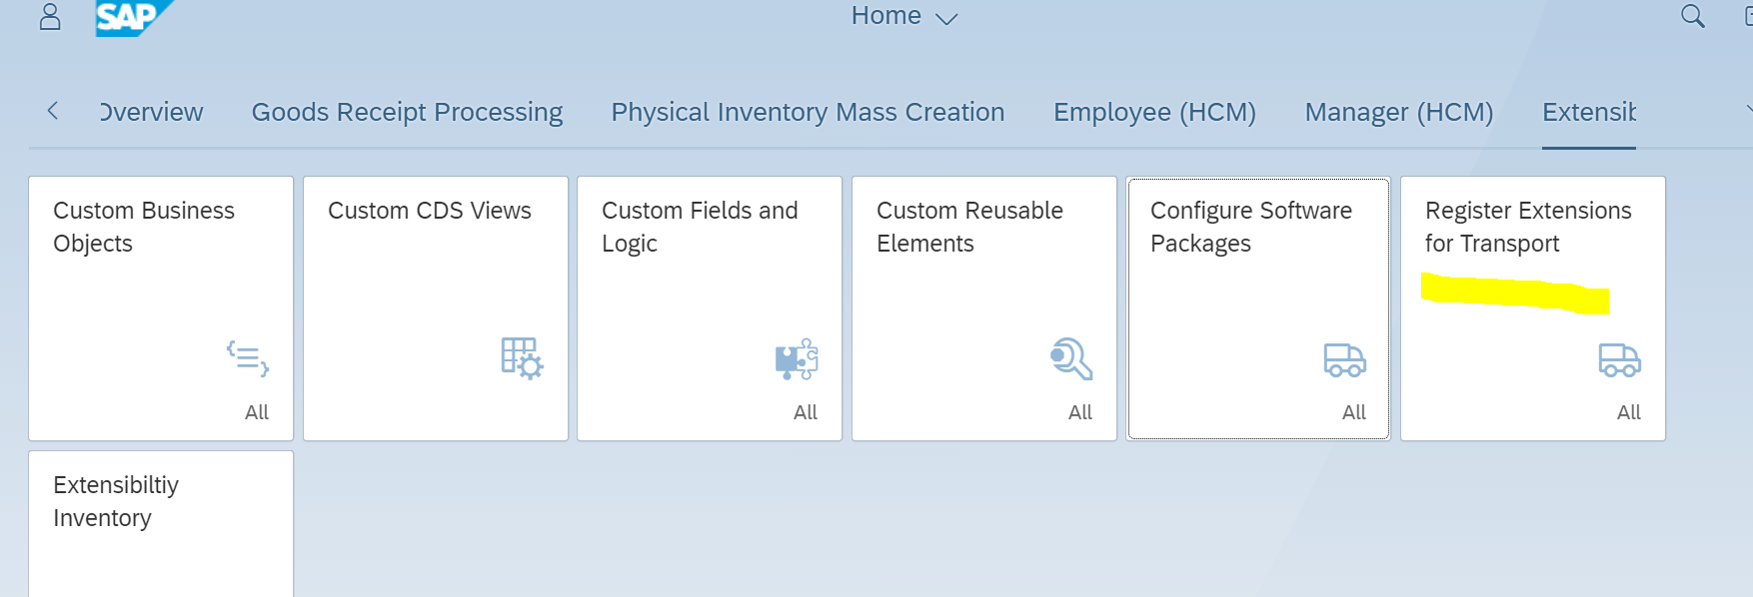

1. New custom field is added in default local package, we need to move it to package and Transport.

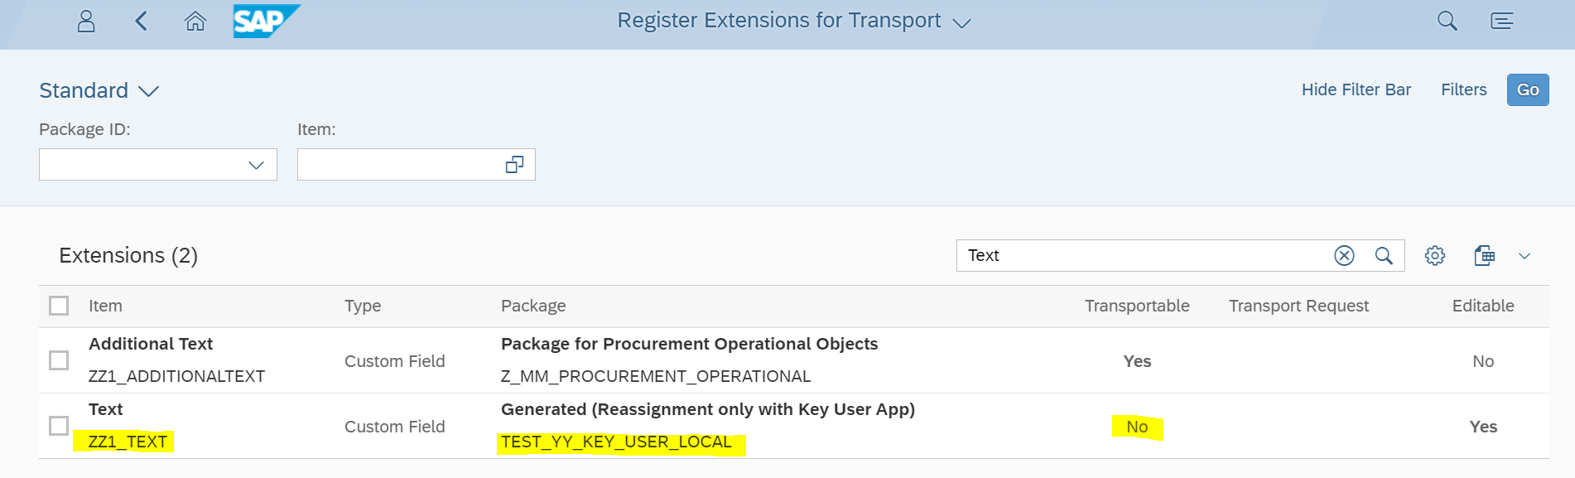

1. Select the custom field and click on Re-assign to Package.

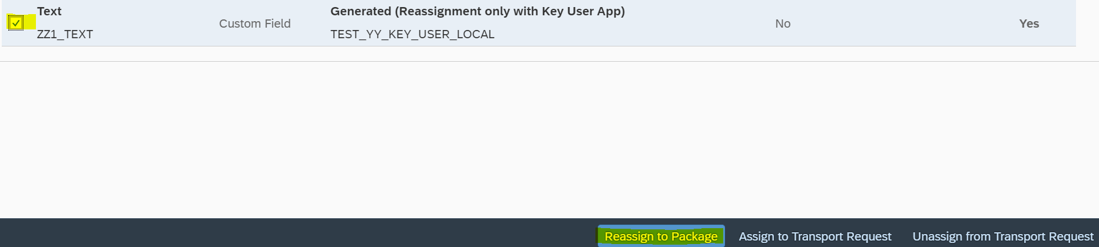

1. In Pop Up screen select the package.

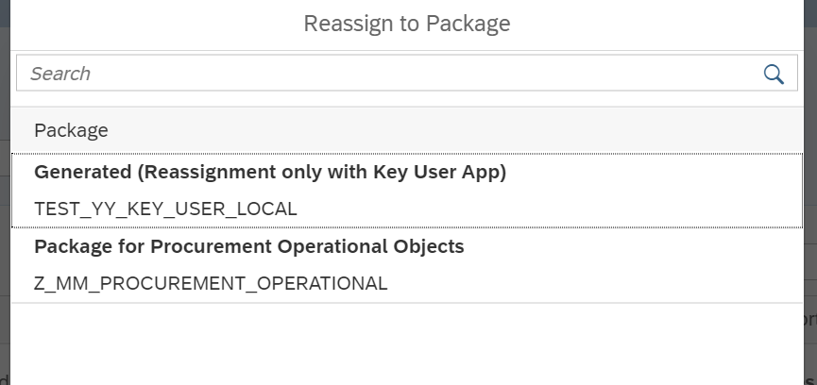

1. If there is no any open task in Transport then System will ask for task.

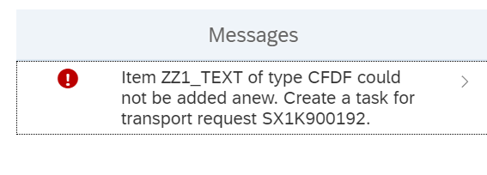

1. After creating task in Transport, custom field will be moved to Transport



1. All these objects added in TR.

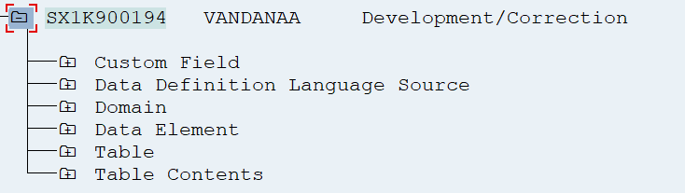

**Adapt UI:**

1. Open the FIORI app - Manage purchase requisition Professional, Using adapt UI option in FIORI launchpad.

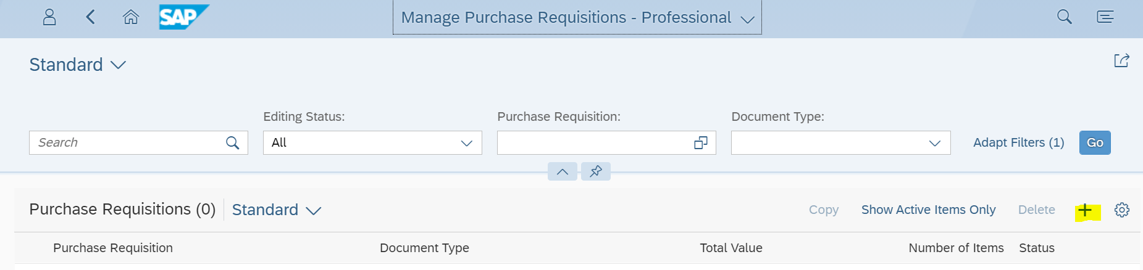

1. Click on create Purchase Requisition by using Add button.

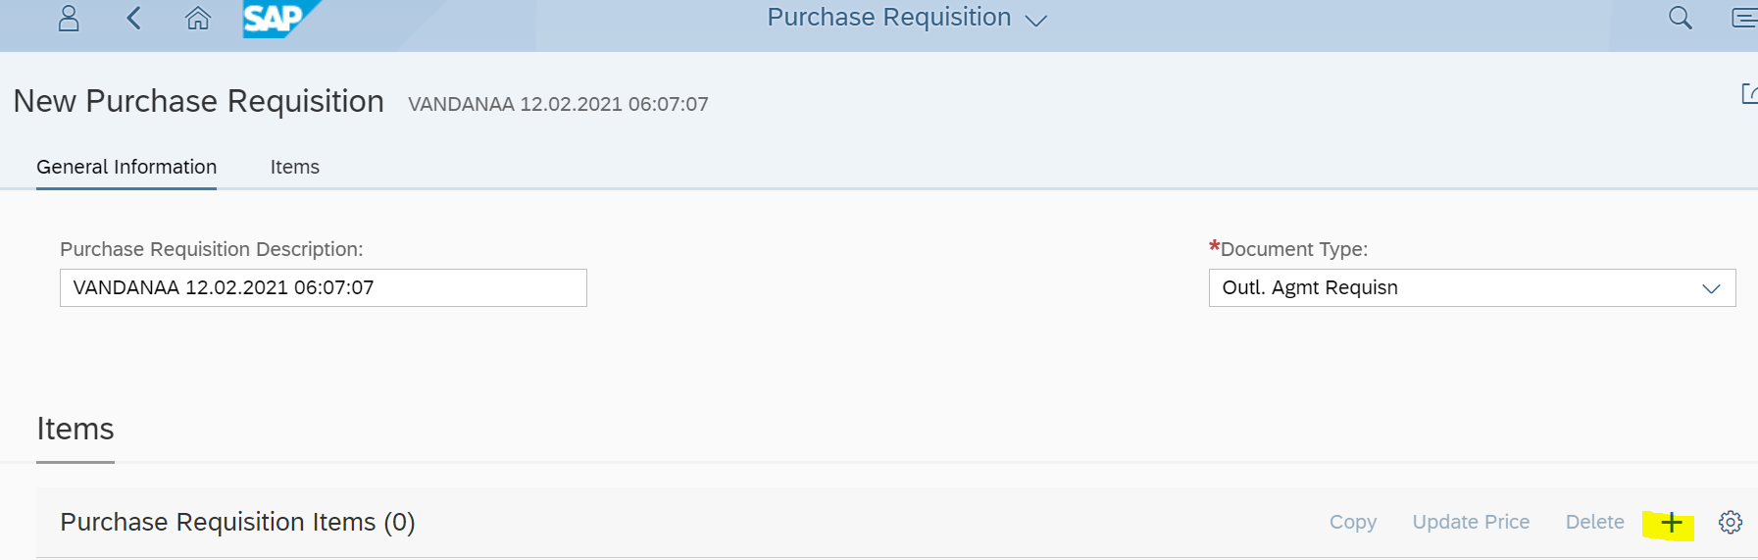

1. Click on plus button, to create purchase requisition item.

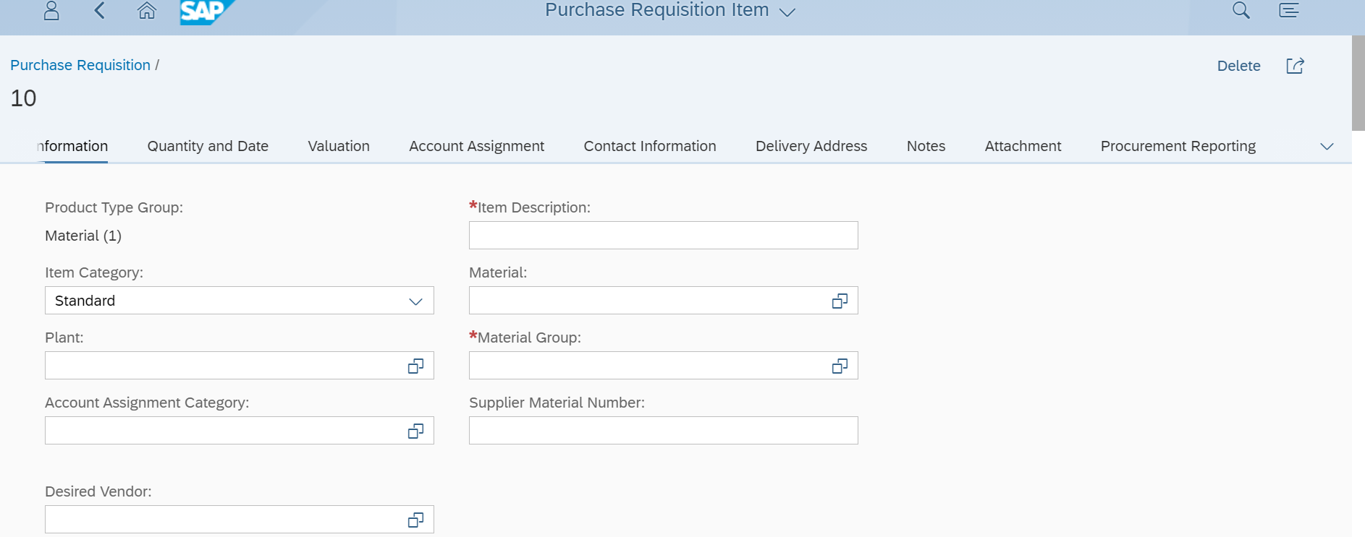

1. Click on User Icon button, we can see Adapt UI button. Click on Adapt UI it will open UI Adaptation screen.

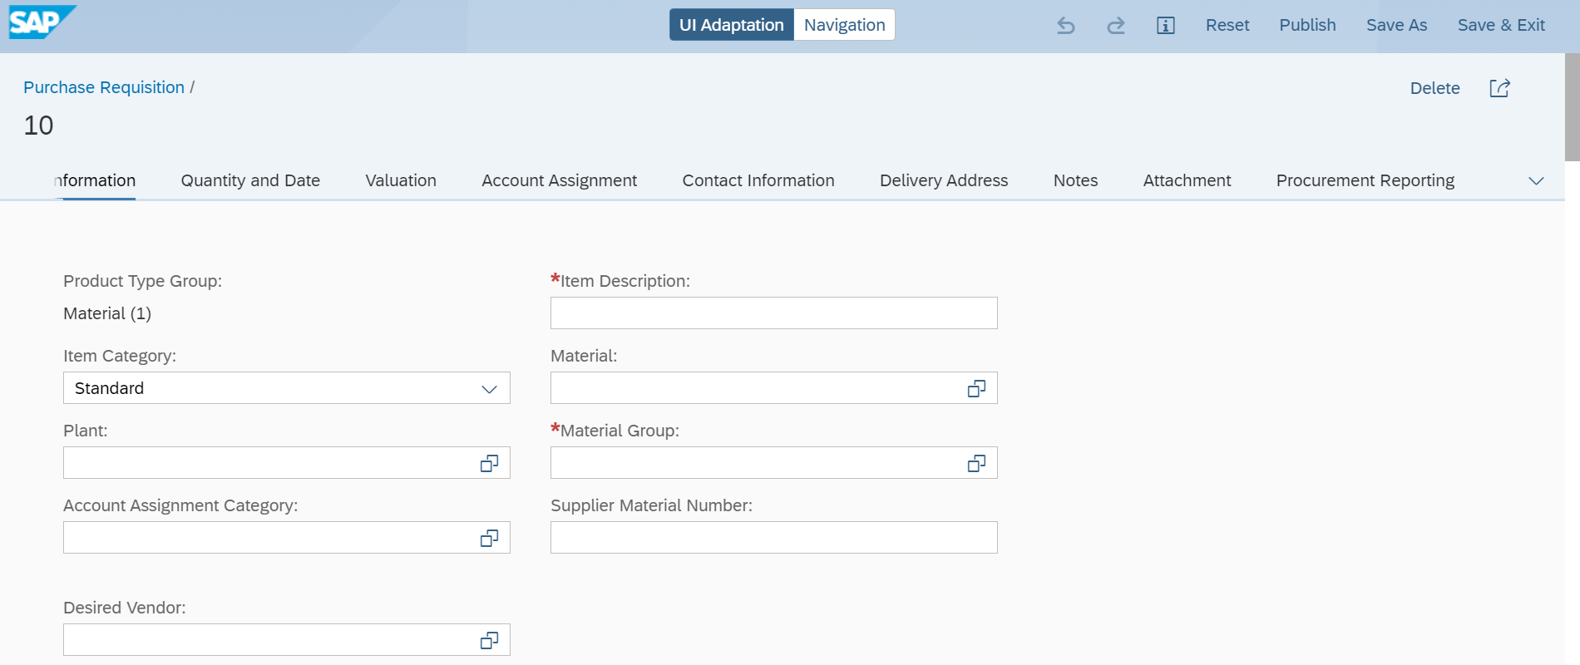

1. Right click on any field, it will open popup. Select Add Field option and then select the field. Field will be added on the screen.

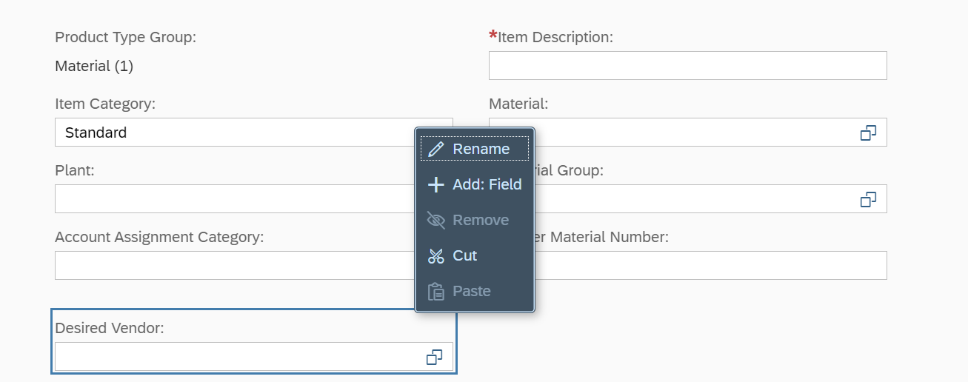

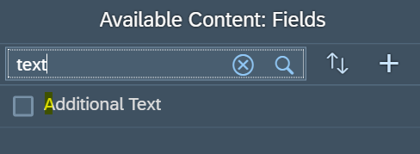

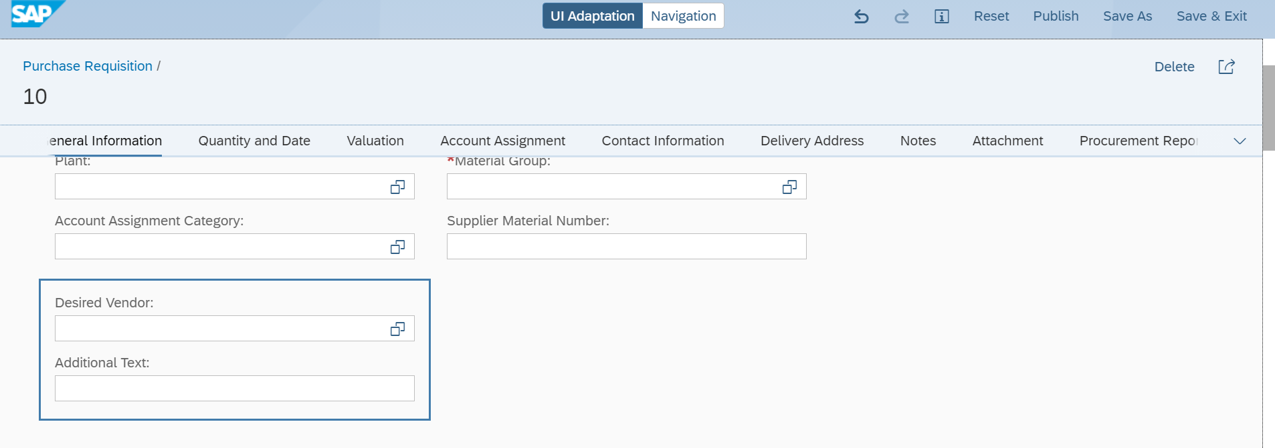

1. Click on publish, changes will be available to all the users.



**Custom Adaptation Project:**

Note: - Before creating adaptation project in Web IDE, we need to create cloud connector and destination.

1. In cloud connector (/sap/bc/lrep) property is mandatory for adaptation projects. We need to provide access to sub folders also.

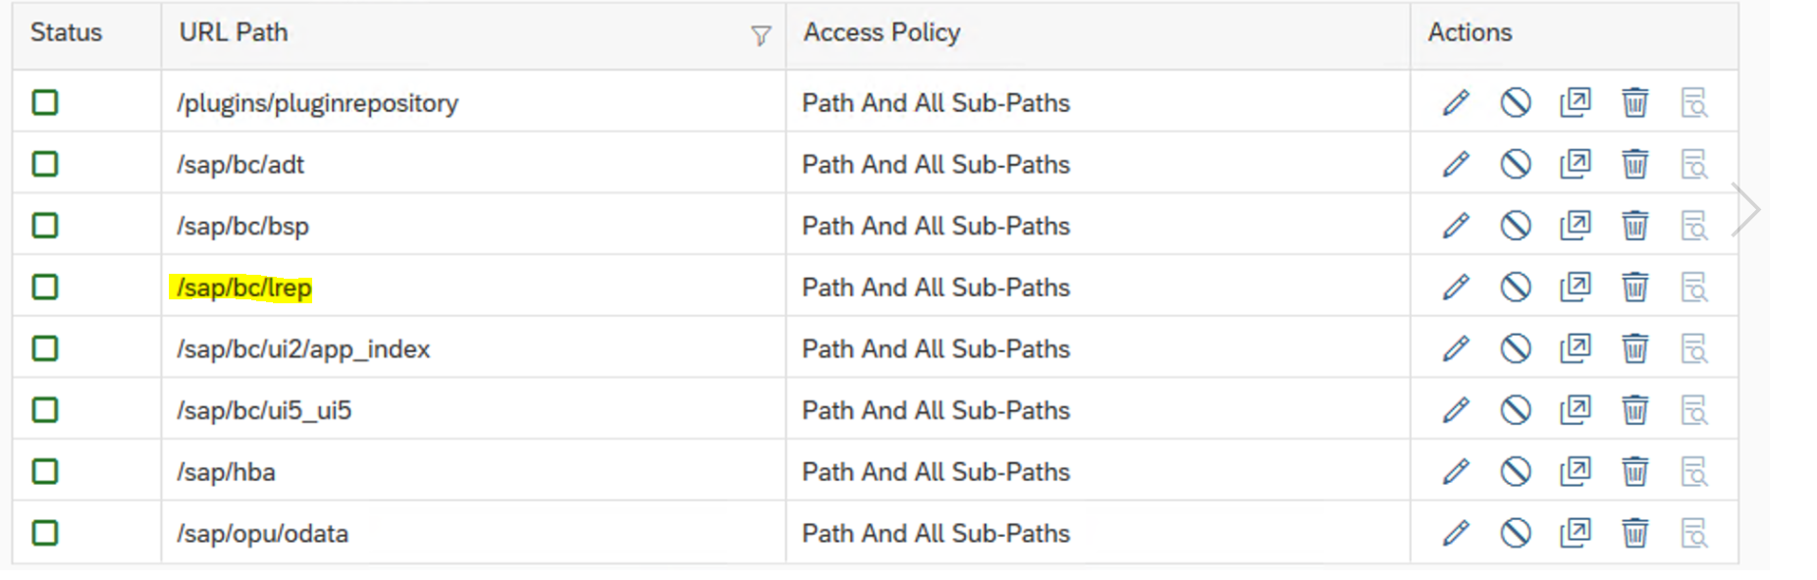

1. We can create Adaptation project for FIORI app, and we can add custom field using that project in FIORI app (F2999- Manage Purchase Requisition Professional App).
2. If we want to add any logic for custom fields like validation, we can do it in Adaptation UI5 project controller using custom field ID.
3. We can write some validation, or any logic related to newly added field in BADI.

MM_PUR_S4_PR_MODIFY_ITEM and BADI ME_PROCESS_REQ_CUST

1. . Fiori app will trigger that BADI while Create and Save operations.

**Troubleshooting:**

1. We can check the fields creation and any issues related to fields TCODE (scfd_fieldviewer). Using this we can repair fields and activate fields.

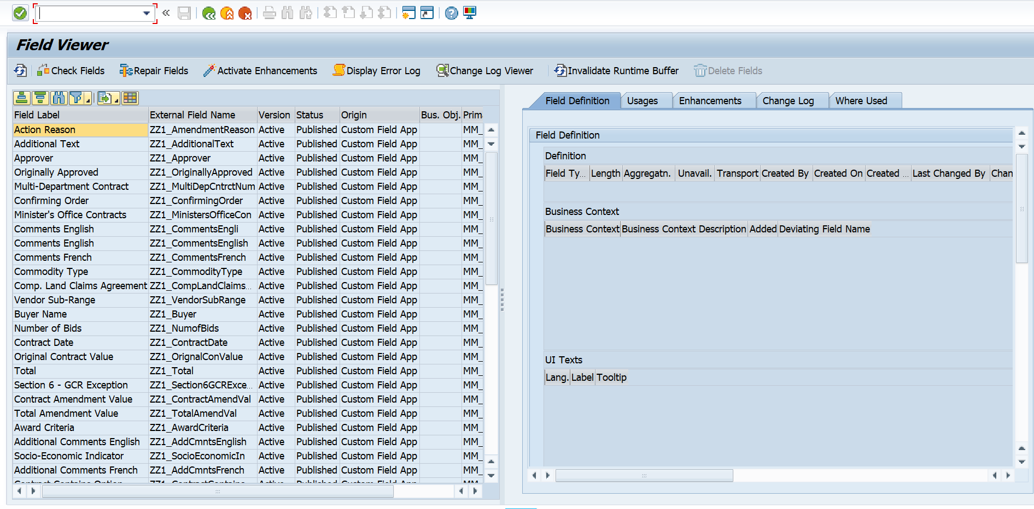

1. If we have added fields names having large names, it will throw errors. Below is the limit for field lengths.

Label - Should be Max Length = 30

ToolTip - Max Length = 40

Value Help Values Max Length =60

**Changes Required from Backend:**

On adding any new field from Custom Field and logic App (for exp. on PREQ Item), a new tab will be created automatically at Item level as below. This tab will contain all fields which are added using custom fields and logic app.



As per business requirements, we may need to do validations or adding default values in fields or manipulating screen fields (for ex. making field input disabled). To cater these kinds of requirements, SAP has provided different BAdIs and Class-Methods though which we can achieve above requirements.

1. **Mandatory Field validations at the time of saving PREQ:**

We have used Badi ME_PROCESS_REQ_CUST for validating fields at the saving PREQ. Earlier this BAdI was getting used only for standard fields validation and fields which are added using screen exit. But SAP has enhanced this BAdI so that it can used for Custom fields added from FIORI.

BAdI- ME_PROCESS_REQ_CUST

Interface Name - IF_EX_ME_PROCESS_REQ_CUST

Method – CHECK

Note: All the validations which we have added in CHECK method, will be triggered on saving PREQ from both GUI transaction and FIORI as well.

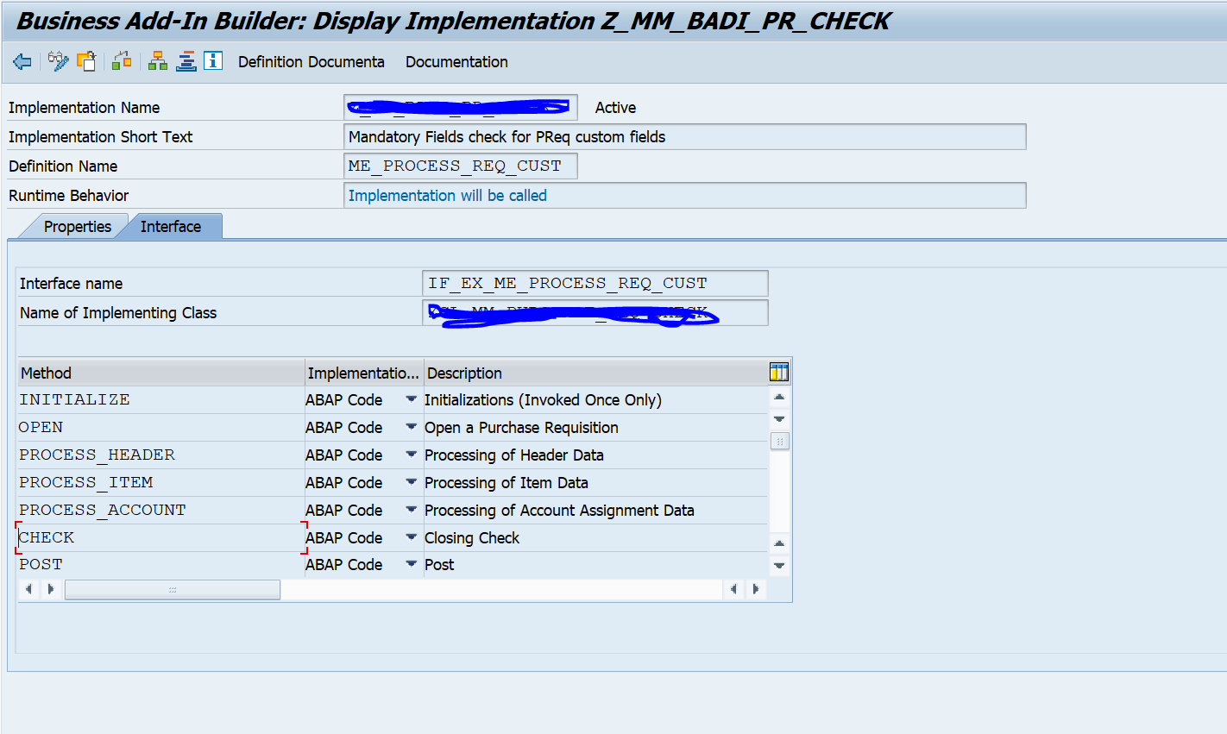

1. **Saving Custom fields values into database after changing it:**

If we need to change values of custom fields so that it can be save in database level as well, SAP has provided BAdI which can be used to achieve this requirement.

BAdI Name - MM_PUR_S4_PR_MODIFY_ITEM

Interface name - MM_PUR_S4_PR_MODIFY_ITEM

Method - MODIFY_ITEM

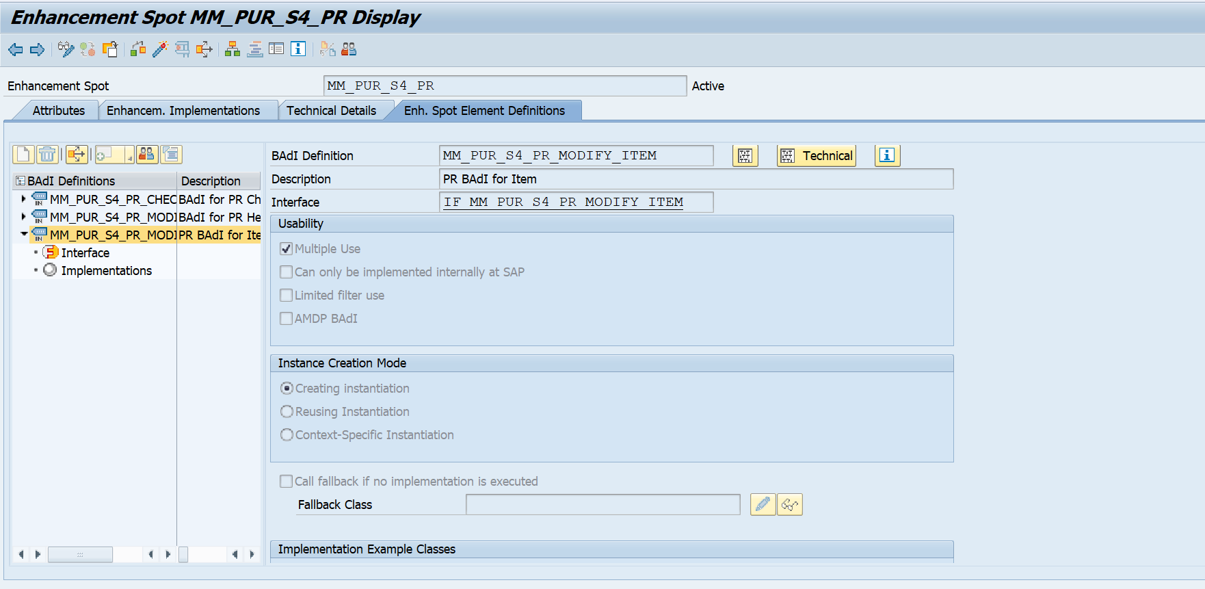

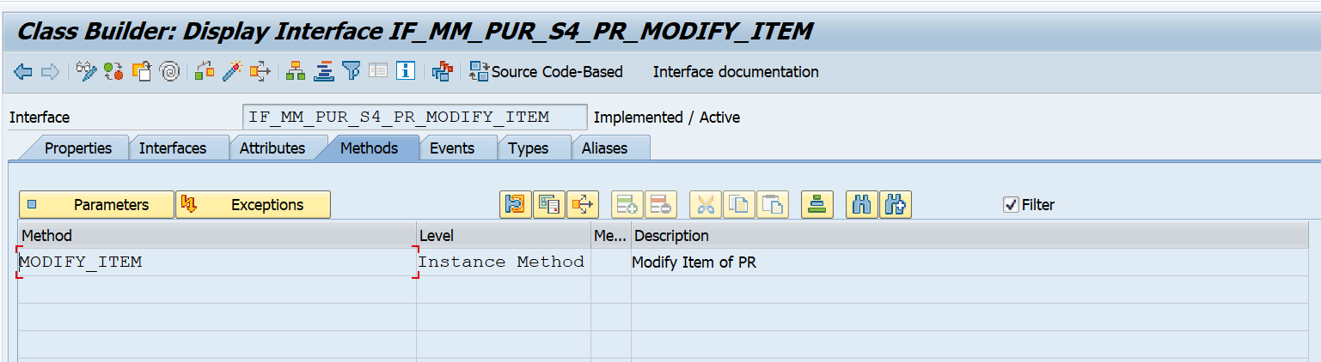

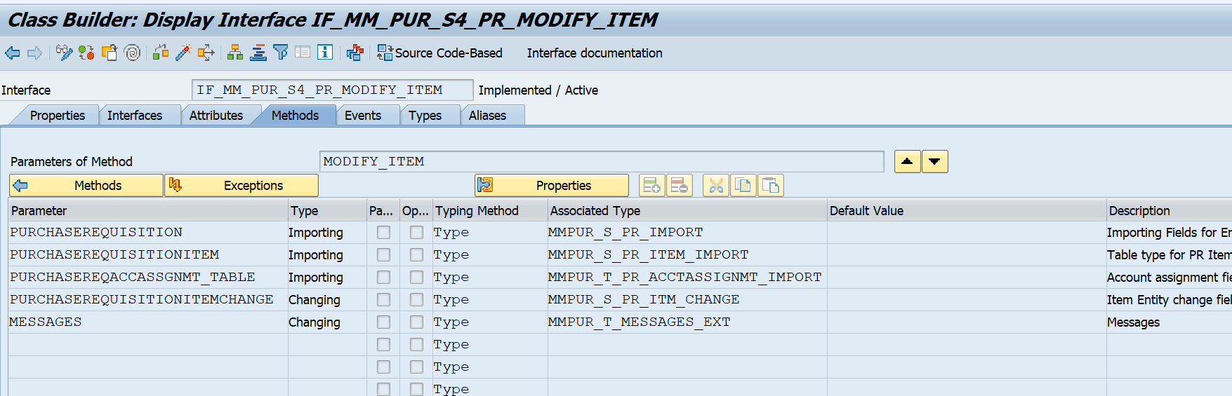

Parameter PURCHASEREQUISITIONITEM contains all fields from EBAN table. Parameter PURCHASEREQUISITIONITEMCHANGE contains all custom fields which is created from FIORI app. We need to use PURCHASEREQUISITIONITEMCHANGE for changing custom fields value and storing value into database.

Note: BAdI related to other TCODES for exp. PO or Contract can be find using TOCDE SCFD_REGISTRY.

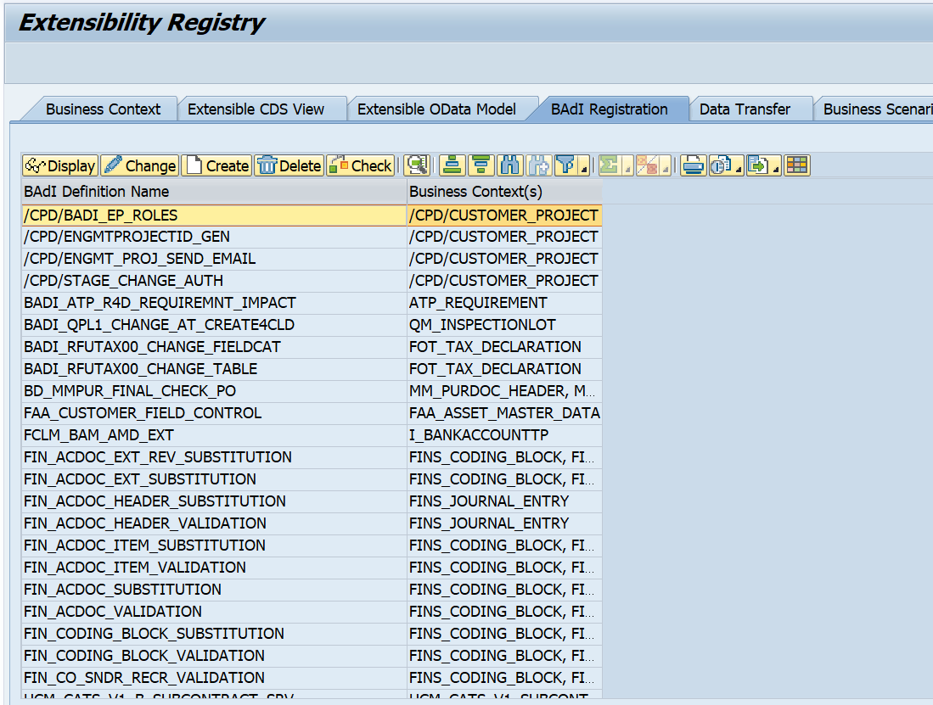

1. **Manipulating Custom fields on screen:**

We can make custom field enable/disable for input or making mandatory based on other field value using class CL_CFD_SAP_GUI_CONTROLLER.

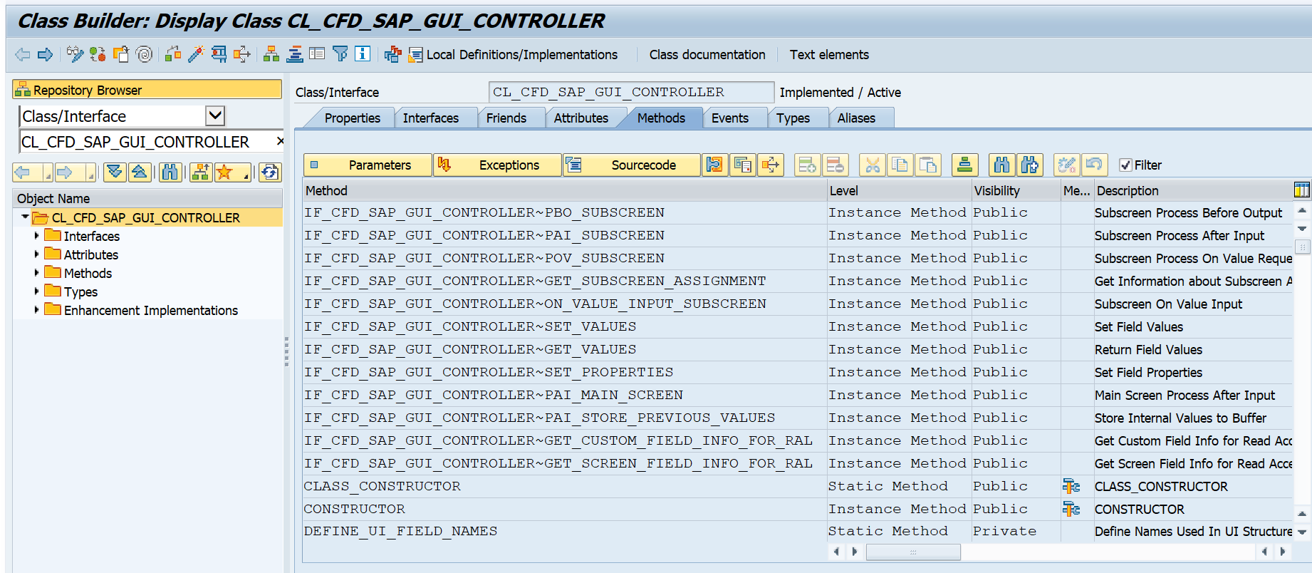

This class has many methods for PBO, PAI and ON Value Input. We have used PBO and ON_VALUE_INPUT_SUBSCREEN for making one field enable/disable based on other field value. Since this is standard class, so we have done implicit enhancement in methods to achieve business requirements.

**Result:**

As part of this business requirement, we have added custom fields at Purchase Requisition Item level using Custom Fields and Logic App.

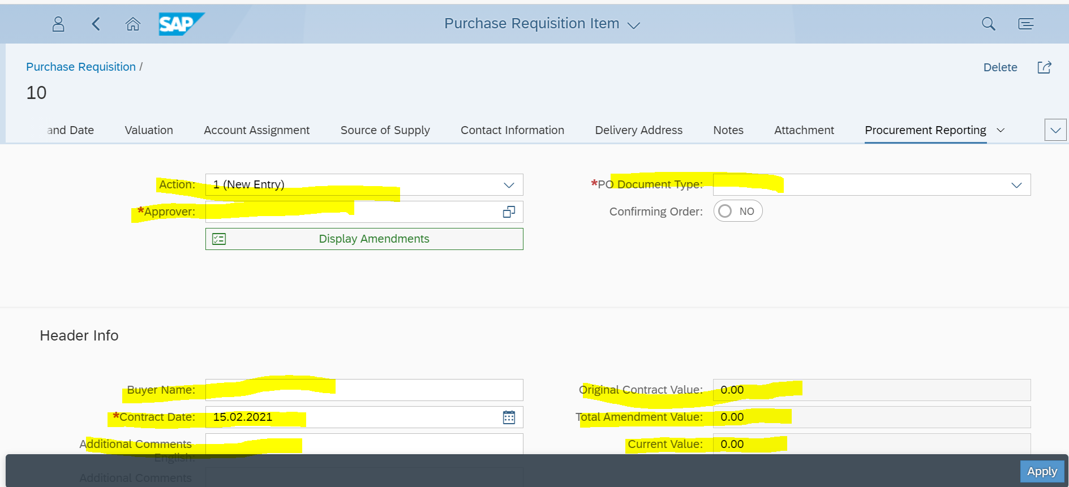

Same fields can be seen in EBAN table and Back-End TCODE.

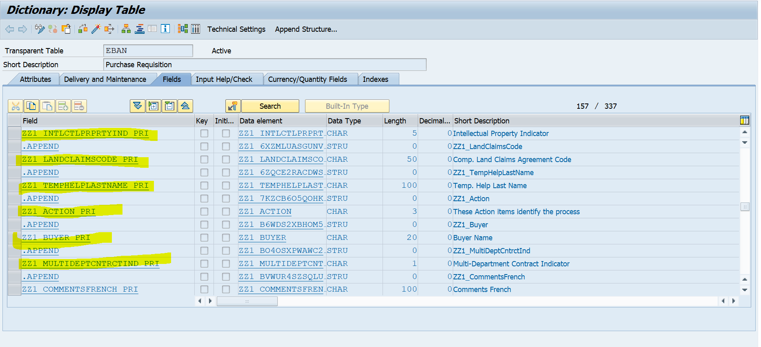

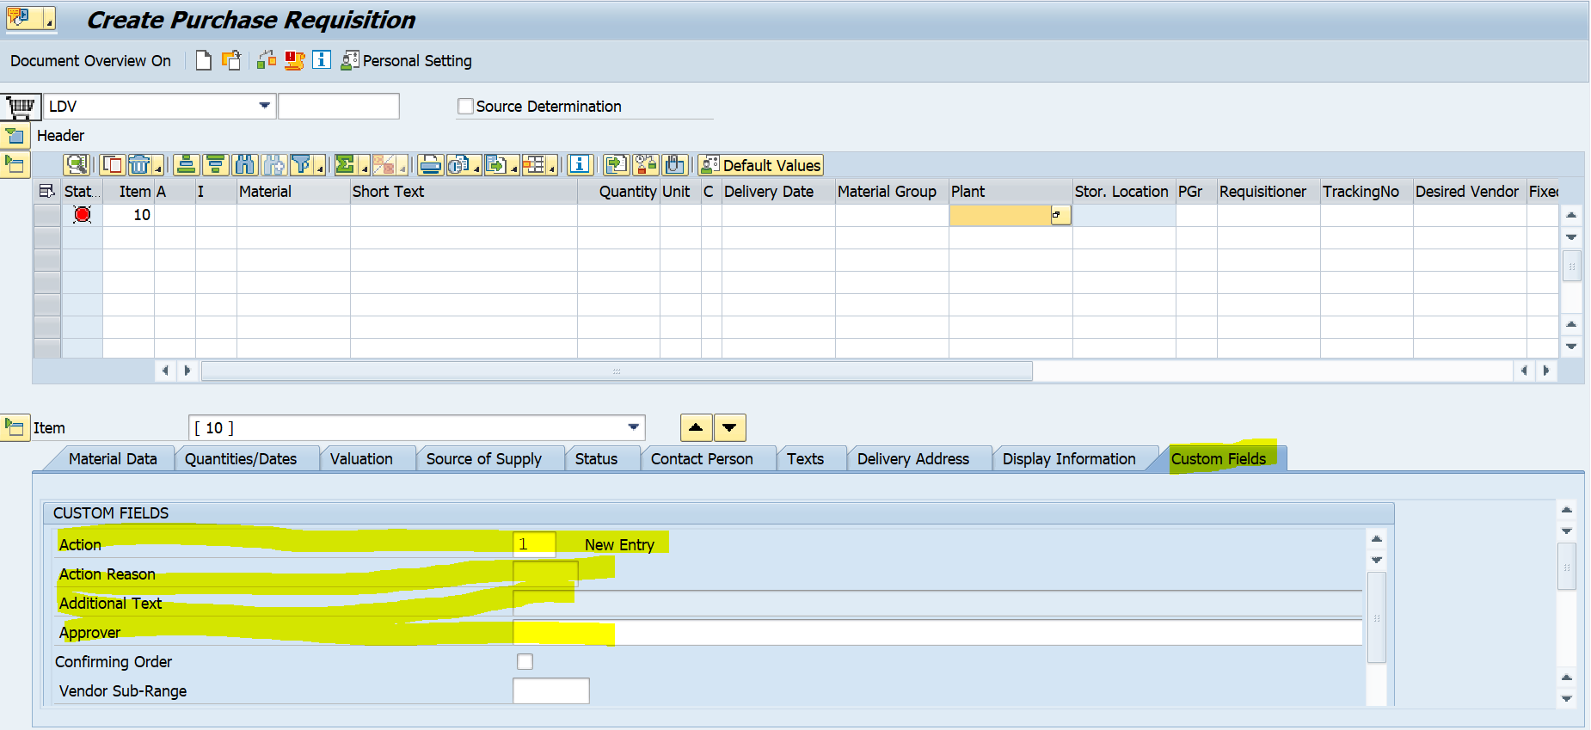

Default values have been filled using BAdI MM_PUR_S4_PR_MODIFY_ITEM for example Action will always has value as ‘1’ whenever Purchase Requisition will be created in both FIORI App and ME51N TCODE.

Mandatory field check is also done using BAdI ME_PROCESS_REQ_CUST.

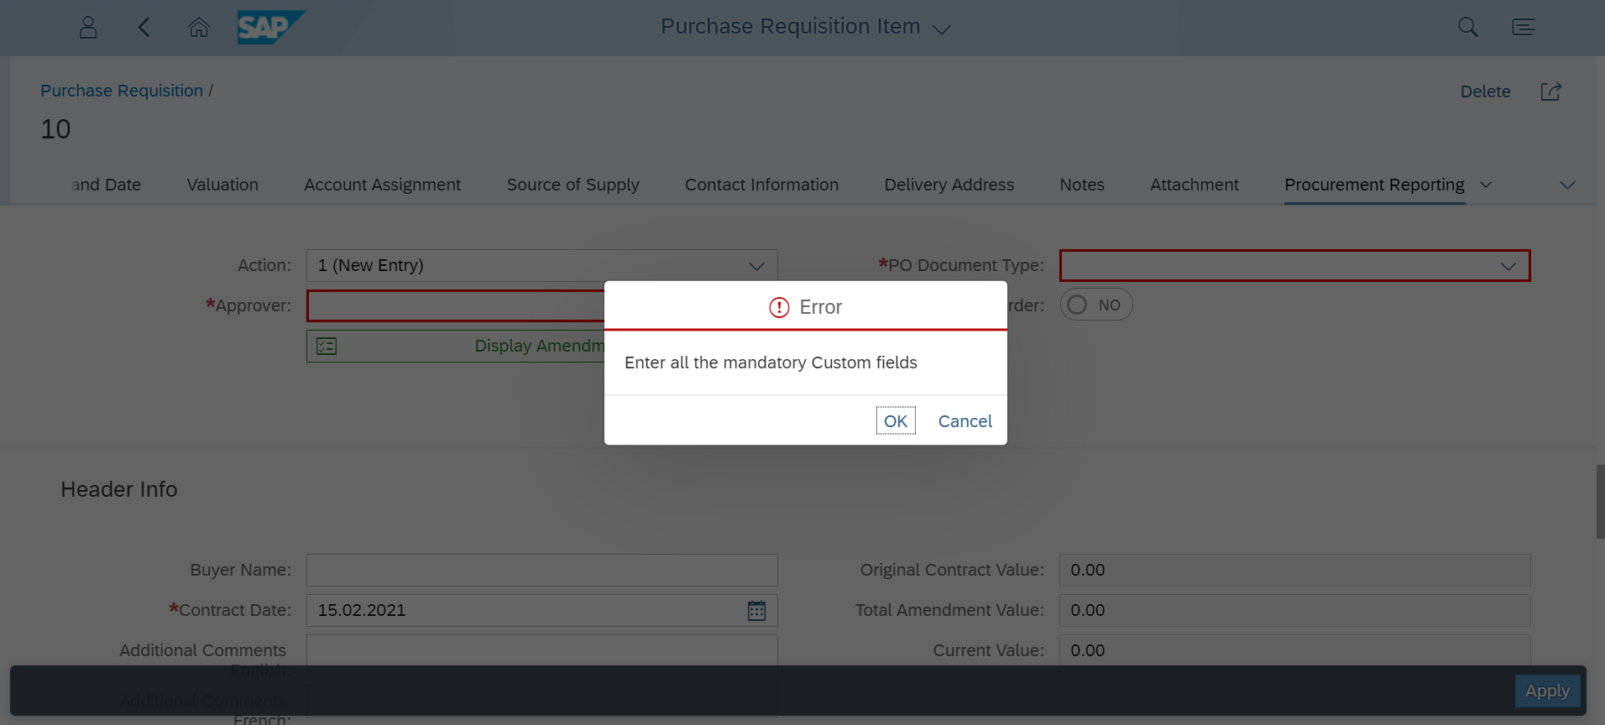

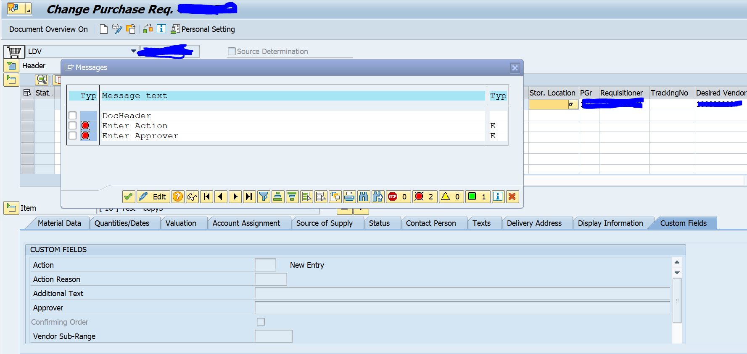

We have used Implicit Enhancement in Standard Class-Method CL_CFD_SAP_GUI_CONTROLLER-~IF_CFD_SAP_GUI_CONTROLLER~PBO_SUBSCREEN.

